VISVESVARAYA TECHNOLOGICAL UNIVERSITY,

##### BELAGAVI - 590018, KARNATAKA.



AN INTERNSHIP REPORT

ON

“WORKING ON FULLSTACK WEB DEVELOPMENT WITH JAVA, MYSQL”

A CASE STUDY

**“Bike Rental: Unleash the Wheels of Wonders"”**

Submitted in the partial fulfillment of the requirements for the award of Degree

#### **B.E. in Computer Science & Engineering**

##### **PROJECT ASSOCIATES**

**Amrutha M Banakar 4BD21CS010**

**Abdulkhadar 4BD21CS400**

**R Kartik 4BD21CS408**

**INTERNAL GUIDE EXTERNAL GUIDE**

**Prof. Kaveri C & Mr. Kashinath Hiremath,**

**Prof. Swetha H U** Program manager,

Assistant Professor, Destination Techs, Bangalore

Department of CS&E, BIET 

#### **Department of Computer Science and Engineering, Bapuji Institute of Engineering & Technology, Davangere- 577004**

**2022-23**

**Bapuji Institute of Engineering and Technology,** **Davanagere - 577004**

#### **Department of Computer Science and Engineering**

CERTIFICATE

This is to certify that **Amrutha M Banakar, R Karthik and Abdulkhadar** bearing USN: **4BD19CS010, 4BD19CS408, 4BD19CS400** respectively of Computer Science and Engineering department have satisfactorily submitted the Internship Project Report entitled “Book Beasts: The Monstrously Efficient Library Catalog System.” in the partial fulfillment of the requirements for the award of Degree of Bachelor of Engineering (B.E.) in Computer Science & Engineering, under the VTU during the academic year 2022-23.

**INTERNSHIP GUIDES**

Prof Kaveri C & Prof. Swetha H U Mr. Kashinatha Hiremath

Internal Guide External Guide

INTERNSHIP CO-ORDINATORS

|  |  |
| --- | --- |
| **Prof. Gangadharappa S** | **Dr. Naresh Patel K M** |
| **Associate Professor** | **Associate Professor** |
| **Department of CS&E** | **Department of CS&E** |

**HEAD OF DEPARTMENT**

|  |  |  |  |
| --- | --- | --- | --- |
|  |  | **Dr. Nirmala C R Ph.D.** |  |
|  |  | **Department of CS&E** |  |

Bapuji Institute of Engineering and Technology, Davangere-577004 Department of Computer Science and Engineering

**Vision and Mission of the Department**

##### **VISION**

To be a center of excellence in imparting state-of-the-art technology in the field of Computer Science and Engineering education enabling the students to become professionally sound and ethically strong.

##### **MISSION**

|  |  |
| --- | --- |
| M1 | Adapting best teaching and learning techniques that cultivates Questioning and  Reasoning culture among the students. |
| M2 | Creating collaborative learning environment that ignites the critical thinking in  students and leading to the innovation. |
| M3 | Establishing Industry Institute relationship to bridge the skill gap and make them  industry ready and relevant. |
| M4 | Mentoring students to be socially responsible by inculcating ethical and moral values. |

###### **PROGRAM EDUCATIONAL OBJECTIVES (PEOs)**

The graduates will be able to

|  |  |
| --- | --- |
| PEO1 | To apply the skills acquired in the field of computer science and engineering in  solving the societal and industrial problems with technology intervention. |
| PEO2 | To continue their career in industry, academia and to pursue higher studies and  research |
| PEO3 | To become successful entrepreneurs, innovators and job creators to design and  develop software products and services to meet the societal, technical and business challenges |
| PEO4 | To work in diversified environment by acquiring leadership qualities with strong  Communication skills along with professional and ethical values |

**PROGRAM SPECIFIC OUTCOMES (PSOs)**

|  |  |
| --- | --- |
| PSO1 | Analyze and develop solutions for problems that are complex in nature but applying  the knowledge acquired from the core subjects of this program. |
| PSO2 | To develop secure, Scalable, Resilient and distributed applications for industry and  Societal requirements. |
| PSO3 | To learn and apply the concepts and construct of emerging technologies like  Artificial Intelligence, Machine learning, Deep learning, Big Data Analytics, IOT, Cloud Computing, etc. for any real time problems. |

**ACKNOWLEDGMENT**

Salutations to our beloved and highly esteemed institute, “**BAPUJI INSTITUTE OF ENGINEERING AND TECHNOLOGY**” for having well-qualified staff and labs furnished with the necessary equipment.

Foremost, we would like to express our sincere gratitude to Mr. Kashinatha Hiremath , Program manager, Destination Techs, Bengaluru, for his guidance and knowledge sharing throughout this journey to carry out the internship project work successfully.

We express our sincere thanks to our faculty mentor Prof. Naveen H M for giving us constant encouragement, support and valuable guidance throughout the course of project without whose guidance this project would not have been achieved.

We express our sincere thanks to our guide Dr. Nirmala C R, who is also our respected H.O.D of Department of Computer Science & Engineering for giving us constant encouragement, support and valuable guidance throughout the course of the project without whose stable guidance this project would not have been achieved.

We express wholehearted gratitude to our Internship Coordinator Dr. Naresh Patel K M and Prof. Gangadharappa S. We wish to acknowledge him, who made our task easy, by providing with his valuable help and encouragement.

We also express our whole hearted gratitude to our principal, Dr. H B Aravind for his moral support and encouragement.

We would like to extend our gratitude to all staff of Department of Computer Science and Engineering for the help and support rendered to us. We have been benefited a lot from the feedback, suggestions given by them.

**Amrutha M Banakar 4BD21CS010**

**Abdulkhadar 4BD21CS400**

**R Kartik 4BD21CS408**

# ABSTRACT

This project was designed to investigate and relate different functional, operational and technical requirement of a dedicated web application for online bike rental system. This System will facilitate the functioning of web-based Rental Bike store. Each type of Bike should have a different rental fee per day. Rental fee depends on number of day, brand and how fast the bike runs.

The system equipped to answer Customer's inquiries about the availability and rental fee of various types of bikes for certain dates in the future. When the customer makes a decision about the type of bike and the Dates, the system should be able to reserve or earmark the requested type of bike for requested dates. The customer should be given a confirmation number.

The system process a bike Pick Up. Customer walks in and supplies either the confirmation number, or name. The system should pull up all the reservation information about this customer. The customer is then asked to supply a drivers license. The system process a return. The system should record the date, time and processed by Depending on these parameters, the system calculate the final rental amount.

Bike Rental System gives bike rental service for both foreign and local customers. This organization carries out its daily work by providing; their service to the customers using manually system. The organization uses a manual system for reserving, renting, register and to keep record of all the rental activities and customer information. It provides Bike reservation facility online. Customer can visit the website and check for various Bikes. If customers are feasible with requirement, then booking can be done.

**Table of Contents**

**` CONTENTS PAGE NO**

**Chapter 1: Introduction 01-06**

* 1. About the Company
  2. Full stack with java
  3. Java Introduction

**Chapter 2: Tasks Performed 06-10**

* 1. Task Performed in Week 1 and 2
  2. Task Performed in Week 3 and 4

## Chapter 4: System Requirements 10-11

### 4.1 Software Requirements

4.1.1 Front End

4.1.2 Back End

4.2 Hardware Requirements

## Chapter 5: System Design 11-13

5.1 E-R Diagram

5.2 Schema Diagram

5.3 Overview of GUI

5.4 Normalization

## Chapter 6: Implementation 13-

6.1 HTML

6.2 CSS

**Chapter 7: RESULTS**

**CONCLUSION**

FUTURE ENHANCEMENT

CHAPTER 1

### INTRODUCTION

###### **About the Company/ Resource Person**

Destination Technologies is a leading provider of software training and professional development solutions, committed to keeping individuals and organizations current with the latest technologies in the IT industry. Their services include online training, corporate training, and classroom training, catering to diverse client needs.

Training and Education Services

Website Development: Destination Technologies offers comprehensive training in website development, covering a range of technologies and skills crucial for success in the IT field.

IT Staffing: The company provides IT staffing services, connecting organizations with top talent to meet their specific business needs and drive success.

Online Training: Recognizing the challenges of geographic dispersion, Destination Technologies offers online training programs, allowing individuals to access high-quality instruction from experienced software developers, irrespective of their location.

Customized Corporate Training: The company specializes in developing customized, client-specific training programs to enhance the skills and productivity of corporate teams, aligning with business objectives.

Vision and Mission

Vision: To be the leading provider of comprehensive software training and professional development solutions, bridging the gap between talent and opportunity in the ever-evolving IT industry.

Mission: To offer cutting-edge software training using the newest technologies, fostering continuous learning for individuals and organizations to unlock their full potential and achieve their goals.

Leadership Team

Mr. Subramanya Raj: An experienced leader with over 5 years of industry experience and 9+ years of teaching experience in software engineering. He has trained over 12,000 students and is well-versed in various technologies.

Mr. Sreedhar Kommuru: A dedicated educationist with a focus on guiding aspirants, helping over 400,000 students excel in competitive exams. His commitment to education has made a significant impact on countless individuals.

Mr. Sudheer Chakravarthy Chaganti: A passionate educator and tech expert, Mr. Chaganti founded Sreedhar's CCE, emphasizing the transformative power of education. He is recognized as an official knowledge partner for renowned platforms.

Key Values

* Continuous learning and staying current with industry trends.
* Customized and client-specific training solutions.
* Connecting organizations with top IT talent.
* Fostering a culture of excellence and collaboration.
* Bridging the gap between talent and opportunity in the IT industry.

Destination Technologies is dedicated to empowering individuals and organizations to thrive in the dynamic and competitive IT landscape through cutting-edge training and development programs.

###### **1.2 Full stack with java**

Full Stack Java development involves proficiency in both frontend and backend technologies within the Java ecosystem. A full-stack Java developer crafts dynamic user interfaces using HTML, CSS, and JavaScript, often relying on frameworks like Angular, React, or Vue.js for enhanced functionality. On the backend, Java serves as the primary programming language, with frameworks such as Spring or Spring Boot facilitating the creation of robust server-side applications.

Database management is a vital aspect of full-stack Java development, with developers interacting with relational databases like MySQL. Technologies such as JDBC or Hibernate are commonly used for efficient database access and management. Servlets play a crucial role in handling server-side logic, managing requests, and generating dynamic content.

Key skills encompass server-side development, including the use of Servlets for handling HTTP requests and responses, RESTful API creation, and database connectivity through JDBC for efficient communication with MySQL databases. The understanding of HTML, CSS, and JavaScript is essential for creating engaging and responsive user interfaces, and proficiency in MySQL ensures effective database operations.

In summary, a full-stack Java developer proficient in HTML, CSS, JavaScript, MySQL, Servlets, DBMS, and JDBC is well-equipped to design and implement both frontend and backend components of a web application, providing end-to-end development expertise.

###### **1.3 Java Introduction**

Java, a versatile programming language, has played a pivotal role in shaping the software development landscape. Developed by Sun Microsystems and currently maintained by Oracle, Java's appeal lies in its object-oriented architecture, facilitating the creation of modular, extensible, and scalable applications.

One of Java's standout features is its commitment to platform independence. Through the Java Virtual Machine (JVM), Java code can be executed on various platforms without modification, ensuring "Write Once, Run Anywhere" capability. This flexibility makes Java an ideal choice for developers working on diverse projects, ranging from web and mobile applications to backend enterprise systems.

Java, a versatile and widely-used programming language, is deeply rooted in the principles of Object-Oriented Programming (OOP). OOP is a paradigm that organizes software design around the concept of objects, encapsulating data and behaviour. Here's how Java embraces OOP:

Classes and Objects:

In Java, everything is an object. Objects are instances of classes, which serve as blueprints for creating objects.

Classes define attributes (fields) and behaviours (methods) that objects can exhibit.

Encapsulation:

Java promotes encapsulation by allowing the bundling of data (fields) and methods that operate on the data within a single unit, i.e., a class.

Access modifiers (public, private, protected) control the visibility of class members, facilitating data hiding.

Inheritance:

Inheritance allows a class (subclass) to inherit properties and behaviours from another class (superclass). Java supports single inheritance (one class extending another) and multiple interfaces.

Polymorphism:

Polymorphism in Java allows objects of different types to be treated as objects of a common type.

Method Overloading: Multiple methods in a class can have the same name but different parameters.

Method Overriding: Subclasses can provide a specific implementation of a method defined in a superclass.

Abstraction: Abstraction involves simplifying complex systems by modelling classes based on the essential properties they share.

Abstract classes and interfaces in Java allow developers to define abstract types that can be extended or implemented by concrete classes.

Encapsulation, Inheritance, and Polymorphism (EIP):

These three principles, collectively known as EIP, form the core tenets of Java's OOP design philosophy.

Encapsulation ensures the bundling of data and methods into cohesive units.

Inheritance enables code reuse and establishes relationships between classes.

Polymorphism allows for flexibility and adaptability in code through method overloading and overriding.

Java's strong adherence to OOP principles provides developers with a powerful and modular approach to software design. By leveraging classes, objects, inheritance, encapsulation, and polymorphism, Java facilitates the creation of modular, maintainable, and extensible software systems.

## CHAPTER 2

### TASK PERFORMED

###### **Task Performed During Week 1 and 2**

HTML:

Basics:

Learn about HTML syntax, elements, and attributes.

Practice creating a basic HTML document.

Understand the purpose of HTML tags like <head>, <body>, <p>, <h1>, etc.

Forms:

Study form elements such as <form>, <input>, <select>, <textarea>.

Learn about form validation and attributes like required.

Multimedia:

Explore embedding images and videos using <img> and <video> tags.

Understand the <audio> tag for embedding sound files.

Tables:

Learn to create tables using <table>, <tr>, <td>, <th> tags.

Understand how to merge cells and create accessible tables.

Semantic HTML:

Familiarize yourself with semantic elements like <header>, <nav>, <article>, <footer>.

Understand their roles in improving website structure and accessibility.

CSS:

Selectors and Styling:

Learn about CSS selectors and how to apply styles to HTML elements.

Practice using properties like color, font-size, margin, padding, etc.

Layout:

Study different layout techniques like Flexbox and Grid.

Learn about positioning and the box model.

Responsive Design:

Understand media queries for creating responsive designs.

Learn about viewport units and flexible layouts.

Transitions and Animations:

Explore CSS transitions and animations for adding interactivity to your designs.

CSS Preprocessors (Optional):

Learn a CSS preprocessor like Sass or Less for more organized and maintainable stylesheets.

JavaScript:

Basic Concepts:

Understand variables, data types, and operators.

Learn about control structures: if, else, switch, loops (for, while).

Functions:

Study function declarations, expressions, and the concept of scope.

Learn about parameters and return values.

DOM Manipulation:

Understand how to manipulate the Document Object Model (DOM) using JavaScript.

Practice selecting and modifying HTML elements dynamically.

Events:

Learn about handling user events (click, submit, etc.).

Understand event delegation for efficient event handling.

AJAX and Fetch API:

Study asynchronous JavaScript and how to make HTTP requests using Fetch API.

Learn about promises and async/await.

###### **2.2 Task Performed During Week 3 and 4**

**Java:**

**Java Basics:**

Understand the syntax, data types, and control flow structures.

Study object-oriented programming (OOP) concepts like classes, objects, inheritance, polymorphism, encapsulation, and abstraction.

**Java Advanced Concepts:**

Learn about exception handling, multithreading, and file I/O.

Study collections framework, generics, and lambda expressions.

**Java EE (Enterprise Edition):**

Explore Java servlets and JavaServer Pages (JSP) for web development.

Understand the basics of JavaBeans and how to use them in a Java EE environment.

**Servlet:**

Learn about servlet and http request and response protocol

Explore other popular libraries and tools in the Java ecosystem.

**Build Tools and Version Control:**

Familiarize yourself with build tools like Maven or Gradle.

Understand version control systems, such as Git.

**MySQL:**

**Database Basics:**

Learn the fundamentals of databases, including concepts like tables, rows, columns, and relationships.

**MySQL Installation and Setup:**

Install MySQL on our machine.

Learn to navigate the MySQL command-line interface.

**SQL (Structured Query Language):**

Study SQL queries for CRUD operations (Create, Read, Update, Delete).

Understand complex SQL queries involving joins, subqueries, and indexing.

**Database Design:**

Explore concepts of normalization and denormalization.

Design a database schema for a given problem.

**MySQL in a Programming Environment:**

Integrate MySQL with Java applications using JDBC (Java Database Connectivity).

**Database Administration:**

Understand basic database administration tasks, such as backup and recovery.

Study user management, permissions, and security.

**CHAPTER 3**

# SYSTEM REQUIREMENTS

## 2.1 Software Requirements

The Software Requirement deal with defining software resource requirements and prerequisites that needs to be installed on a computer to provide optimal functioning of an application.

### 2.1.1 Front End

* User interface : HTML/CSS/JavaScript
* Operating System : Microsoft Windows 7 or above
* Web Browser : Chrome, Internet Explorer

### 2.1.1 Back End

* Programming language : Java / J2EE,JavaScript
* Database : My SQL
* Application Server : XAMPP server(v3.2.2) for Apache server (localhost)
* PHP (v7.2.10) for server side scripting
* Sublime3 (Source Code Editor)

## 2.2 Hardware Requirements

The software should run on any sort of desktop or laptop environment, regardless of the operating system. Essential input/output devices are keyboards, mouse, and printers; nothing else is required but can be recommended if desired.

* Processor : Pentium IV and above
* Hard Disk: 100 GB
* RAM : 2 GB or above
* Display Resolution : 1366 x 768 (1920 x 1080 Recommended)
* Other standard physical devices like keyboard, mouse etc

**CHAPTER 4**

**SYSTEM DESIGN**

System designs the process of defining the architecture, modules, interfaces and data for a system to satisfy specific requirements. System design could be seen as the application of system theory to product development. There is some overlap with the disciplines of systems analysis, systems architecture and systems engineering.

## 3.1 Entity – Relationship Diagram

An Entity Relationship model, also called as Entity – Relationship (ER) Diagram, is a graphical representation of entities and their relationship to each other, typically used in computing in regard to the organization of data within databases or information systems.

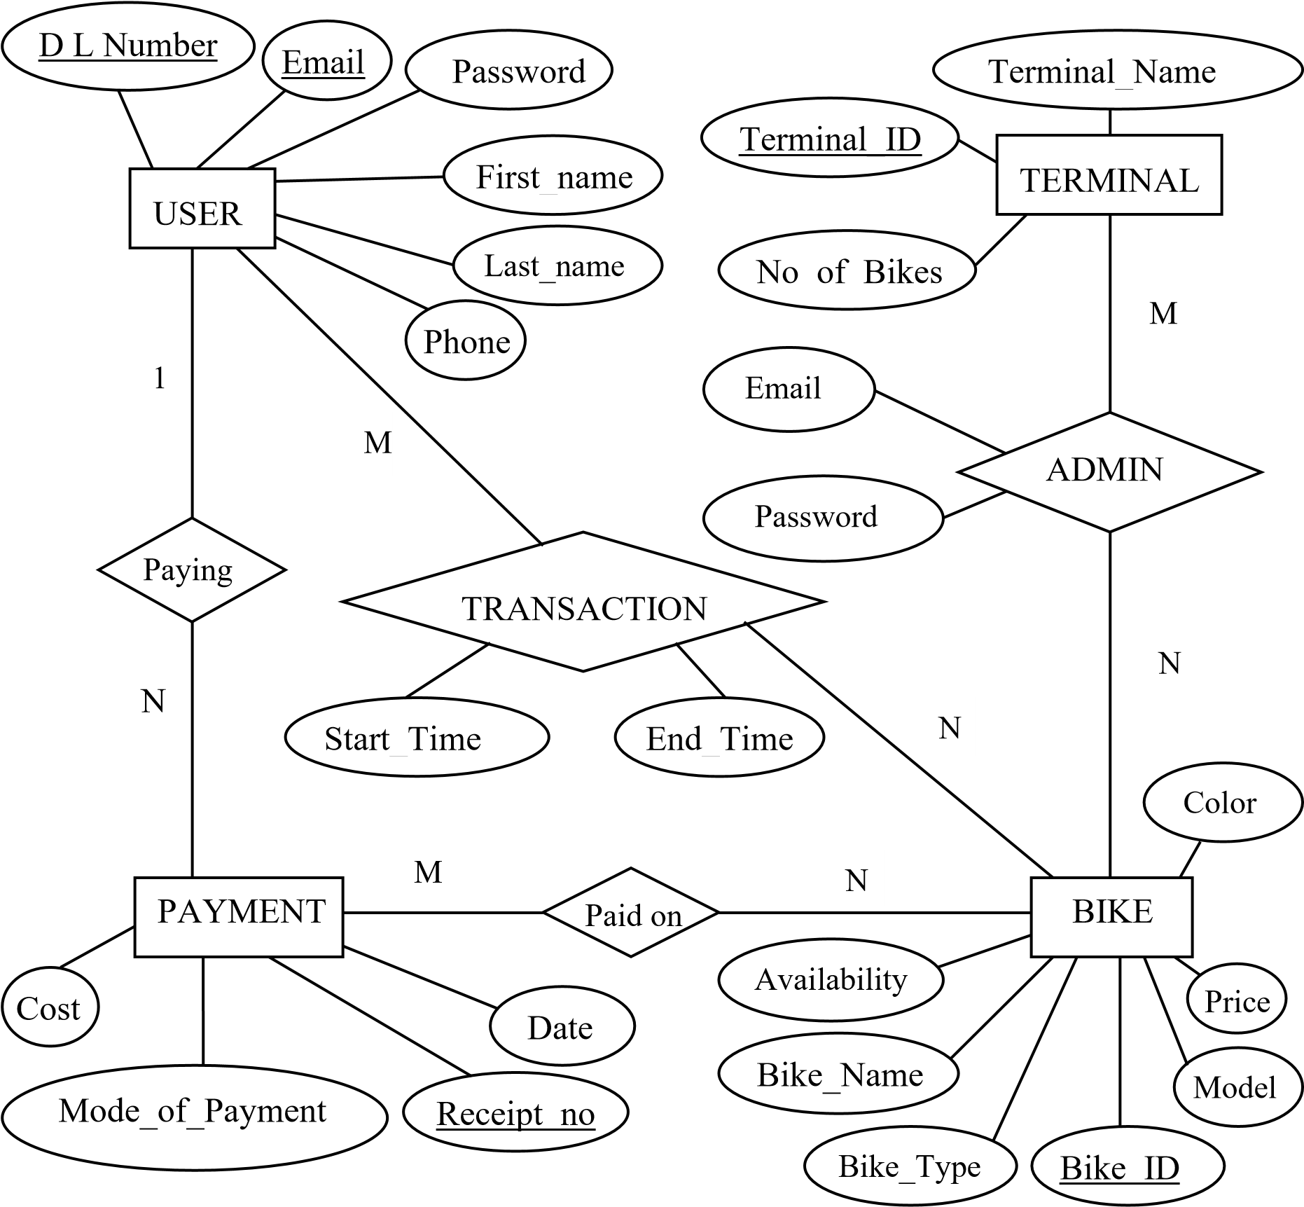

Fig 3.1 ER Diagram

## 3.2 Schema Database Relationship Diagram

A Database schema is the skeleton structure that represents the logical view of the entire database. It formulates all the constraints that are to be applied on the data. A database schema defines its entities and the relationship among them. It contains a descriptive detail of the database, which can be depicted by means of schema diagrams.

### ADMIN

|  |  |
| --- | --- |
| Email | Password |

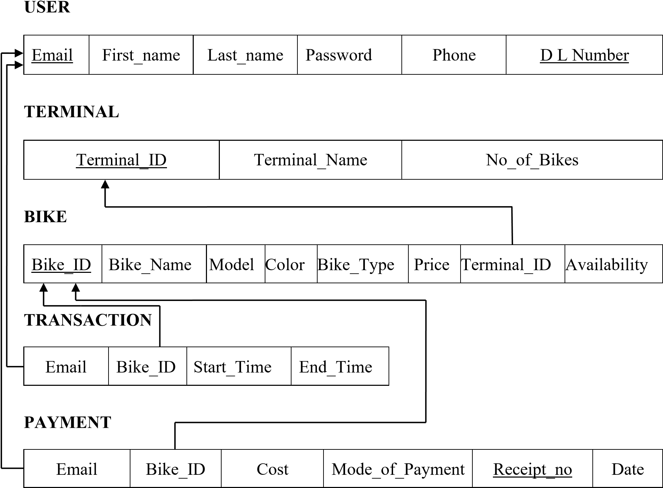

Fig. 3.2 Schema Database Relationship Diagram

## 3.3 Overview of GUI

A graphical user interface (GUI) is an interface for the user to communicate with a computer application using graphical symbols rather than typing the instructions in. The GUI of the proposed Bike Rental system will be developed using HTML5, CSS and PHP (PHP Hypertext Processor).

Hypertext Markup Language (HTML) is the standard markup language for creating web pages and web applications. HTML elements are the building blocks of HTML pages. With HTML constructs, images and other objects, such as interactive forms, may be embedded into the rendered page. It provides a means to create structured documents by denoting structural semantics for text such as headings, paragraphs, lists, links, quotes and other items. HTML elements are delineated by tags,written using angle brackets. The Bike Rental system uses HTML as the building blocks for creating UI elements.

Cascading Style Sheets (CSS) is a style sheet language used for describing the presentation of a document written in a markup language. CSS is used to format the pages to make it appealing to the user. CSS is designed primarily to enable the separation of presentation and content, including aspects such as the layout, colours and fonts. The Bike Rental system application uses Bootstrap 4.1 a boilerplate designed with CSS to reduce development times on the GUI design.

PHP (PHP Hypertext Processor) is a server-side scripting language used to dynamically create webpages. PHP code may be embedded into HTML code, or it can be used in combination with various web template systems, web content management systems, and web frameworks. PHP code is usually processed by a PHP interpreter implemented as a module in the web server or as a Common Gateway Interface (CGI) executable. The web server combines the results of the interpreted and executed PHP code, which may be any type of data, including images, with the generated web page. PHP code may also be executed with a command-line interface (CLI) and can be used to implement standalone graphical applications. The Bike Rental system uses PHP for interacting with the database using MySQL and to display dynamic content on the webpage based on the users queries.

Chapter 4

# IMPLEMENTATIONS

HTML Code

Index.html

<!DOCTYPE html>

<html lang="en">

<head>

<meta charset="UTF-8">

<meta name="viewport" content="width=device-width, initial-scale=1.0">

<link rel="stylesheet" href="index.css">

<link rel="stylesheet"

href="https://cdn.jsdelivr.net/npm/boxicons@latest/css/boxicons.min.css">

<title>Document</title>

</head>

<body>

<header>

<a href="#" class="logo"><img src="img/bx-cycling.svg" alt=""></a>

<div class="bx bx-menu" id="menu-icon"></div>

<ul class="navbar">

<li><a href="#home">Home</a></li>

<li><a href="#ride">Ride</a></li>

<li><a href="#services">Services</a></li>

<li><a href="#about">About</a></li>

<li><a href="#reviews">Reviews</a></li>

</ul>

<div class="header-btn">

<a href="#" class="sign">Sign Up</a>

<a href="#" class="sign-in">Sign In</a>

</div>

</header>

<section class="home" id="home">

<div class="text">

<h1><span>Looking </span>to <br>rent a Bike</h1>

<p>Lorem ipsum dolor sit, amet consectetur adipisicing elit. Illo, rerum nam?</p>

<div class="app-stores">

<img src="https://res.cloudinary.com/swiggy/image/upload/fl_lossy,f_auto,q_auto,h_108/play_ip0jfp" alt="">

<img src="https://res.cloudinary.com/swiggy/image/upload/fl_lossy,f_auto,q_auto,h_108/iOS_ajgrty" alt="">

</div>

</div>

<div class="form-container">

<form action="">

<div class="input-box">

<span>Location</span>

<input type="search" name="" id="" placeholder="Search Places">

</div>

<div class="input-box"><span>Pick-Up Date</span>

<input type="date" name="" id=""></div>

<div class="input-box"><span>Return Date</span>

<input type="date" name="" id=""></div>

<input type="submit" name="" id="" class="btn">

</form>

</div>

</section>

<section class="ride" id="ride">

<div class="heading">

<span>How Its Work</span>

<h1>Rent with 3 Easy Steps</h1>

</div>

<div class="ride-container">

<div class="box">

<i class="bx bxs-map"></i>

<h2>Choose a location </h2>

<p>Lorem ipsum dolor sit amet consectetur adipisicing elit.

Doloribus reiciendis et est, cum officiis voluptate.</p>

</div>

<div class="box">

<i class="bx bxs-calendar-check"></i>

<h2>Pick-Up Date </h2>

<p>Lorem ipsum dolor sit amet consectetur adipisicing elit.

Doloribus reiciendis et est, cum officiis voluptate.</p>

</div>

<div class="box">

<i class="bx bxs-calendar-star"></i>

<h2>Book A Bike </h2>

<p>Lorem ipsum dolor sit amet consectetur adipisicing elit.

Doloribus reiciendis et est, cum officiis voluptate.</p>

</div>

</div>

</section>

CSS Code

Style.css

*{

margin: 0;

padding: 0;

box-sizing: border-box;

scroll-behavior: smooth;

scroll-padding-top: 2rem ;

list-style: none;

text-decoration: none;

font-family: 'Poppins', sans-serif;

}

:root{

--main-color:#fe5b3d;

--second-color:#ffac38;

--text-color:#444;

--gradinet: linear-gradient(#fe5b3d, #ffac38);

}

html::-webkit-scrollbar{

background: 0.5rem;

}

html::-webkit-scrollbar-track{

background: transparent;

}

html::-webkit-scrollbar-thumb{

background: var(--main-color);

border-radius: 5rem;

}

section{

padding: 50px, 100px;

}

header{

position: fixed;

width: 100%;

top: 0;

right: 0;

z-index: 1000;

display: flex;

align-items: center;

justify-content: space-between;

background: #eeeff1;

padding: 15px 100px;

}

.logo img{

width: 40px;

}

.navbar{

display: flex;

}

.navbar li{

position: relative;

}

.navbar a{

font-size: 1rem;

padding: 10px 20px;

color: var(--text-color);

font-weight: 500;

}

.navbar a::after{

content: '';

width: 0;

height: 3px;

background: var(--gradinet);

position: absolute;

bottom: -4px;

left: 0;

transition: 0.5s;

}

.navbar a:hover::after{

width: 100%;

}

#menu-icon{

font-size: 24px;

cursor: pointer;

z-index: 10001;

display: none;

}

.header-btn a{

padding: 10px 20px;

color: var(--text-color);

font-weight: 500;

}

.header-btn .sign-in{

background: #474fa0;

color: #FFF;

border-radius: 0.5rem;

}

.header-btn .sign-in:hover{

background: var(--main-color);

}

.home{

width: 100%;

min-height: 100vh;

position: relative;

background: url(img/motorbike.jpg);

background-repeat:no-repeat ;

background-position: center right;

background-size: cover;

display: grid;

align-items: center;

grid-template-columns: repeat(2, 1fr);

}

**CHAPTER 5**

# RESULTS

**1. Homepage**

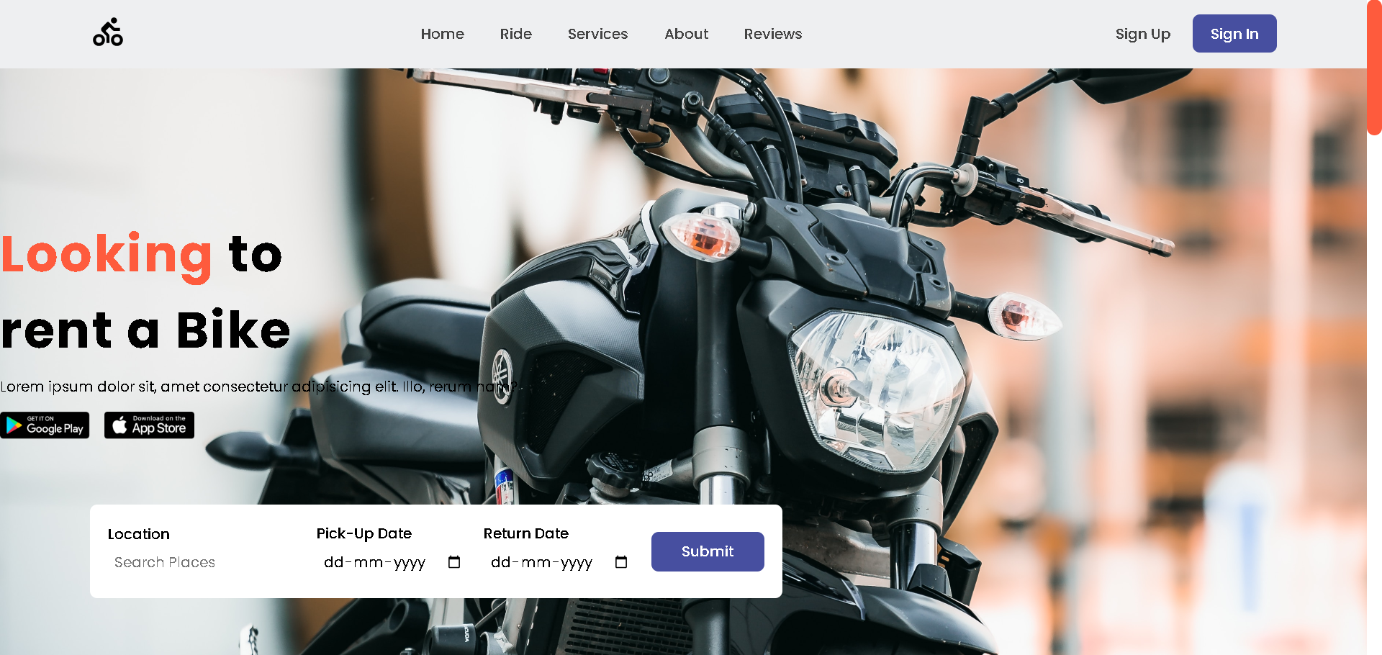

Figure 5.1 Homepage of the application

Existing user can login or can register as a new user. It also provides Admin Login **2. User Login**

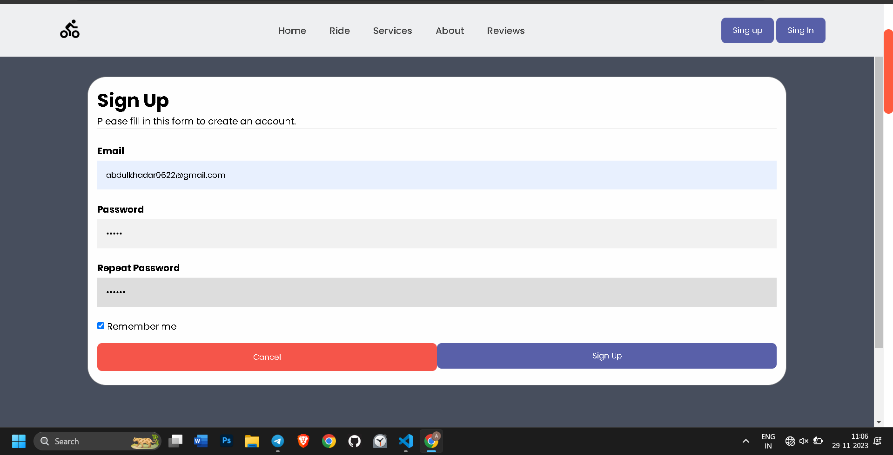

Figure 5.2 Login page for User login

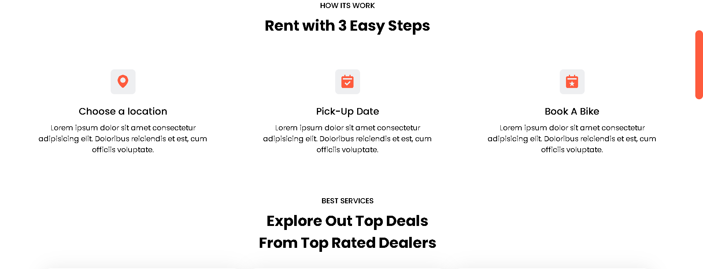

.

## 4. Bike Selection

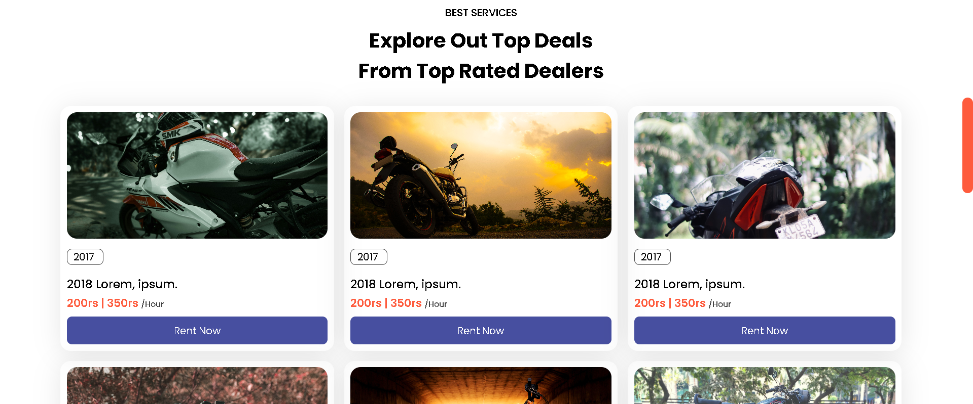

Figure 5.4 Search result page where user makes a selection

Results from the user’s search is displayed here where user can select one from the list. **5.**

## 7. About Page

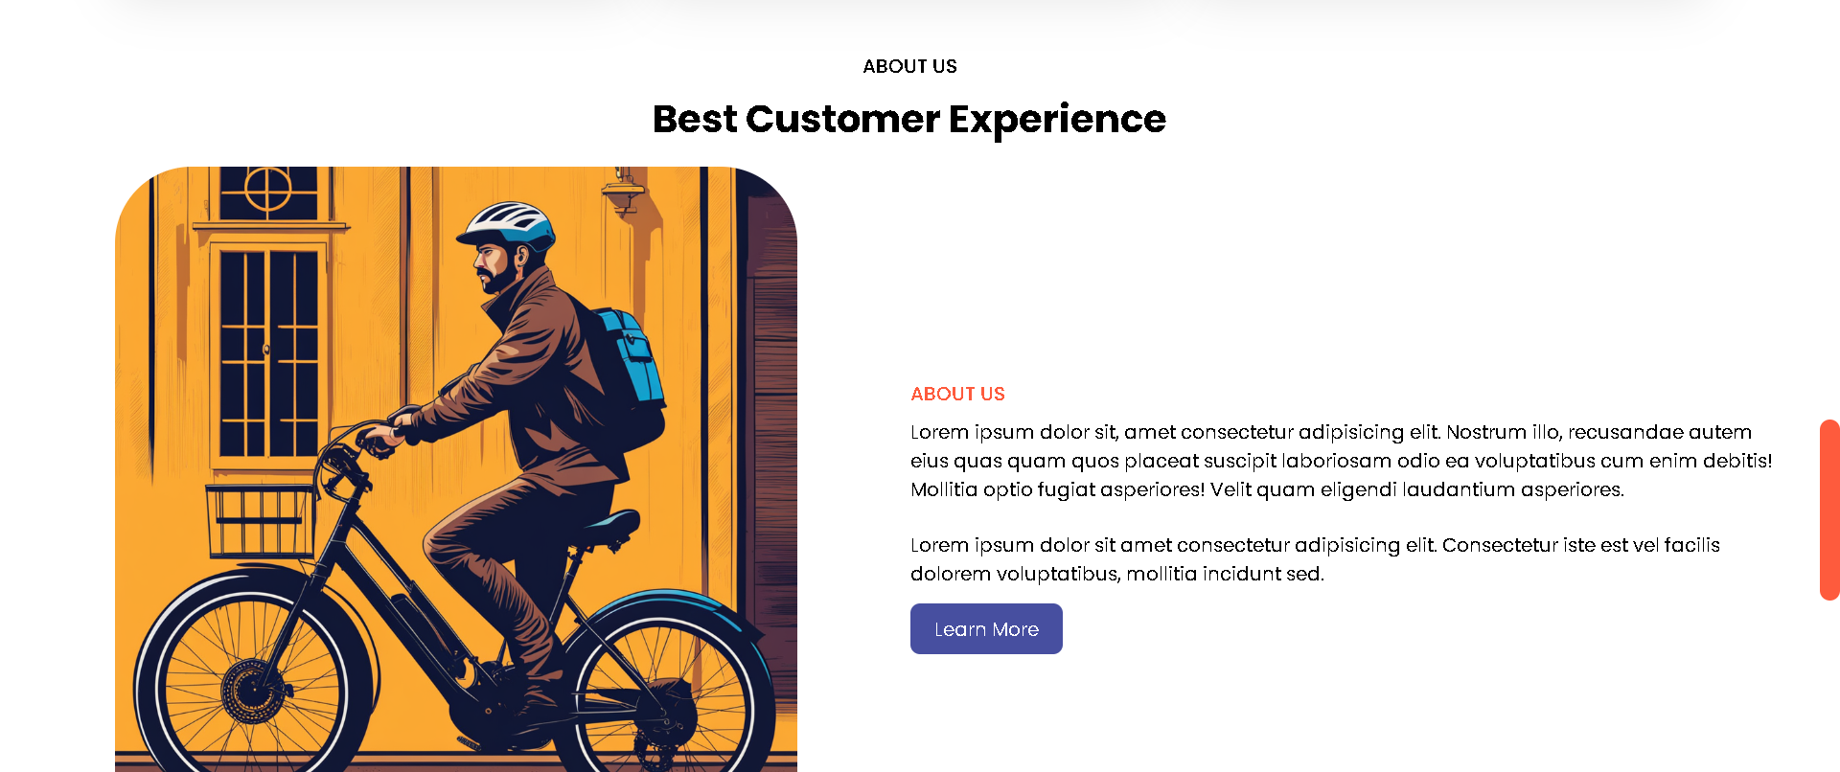

Figure 5.7 about homepage

## 8. Reviews

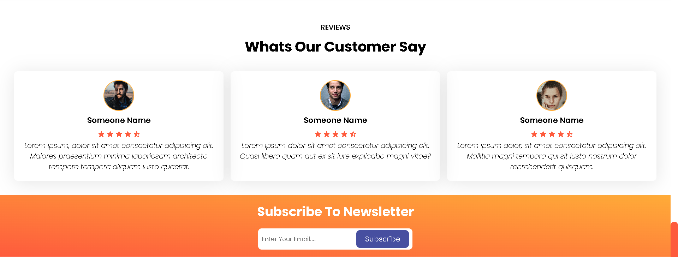

# CONCLUSION

Bike Rental System is a web application and it is restricted to only limited type of users. In this application, Admin have been given access rights and are restricted up to certain functionalities, so that the data is maintained securely and redundant data is prevented. As the Data is stored electronically, it is necessary to have a Computer and Network connection to access the Application. It is a software which helps the user to rent bike base on their need. This software reduces the amount of manual data entry and gives greater efficiency. The User Interface of it is very friendly and can be easily used by anyone. It also decreases the amount of time taken to write details and other modules. At the end, this software can perform all the tasks accurately and can do the work for which it is made.

FUTURE ENHANCEMENT

Once the final Bike Rental System is built, business students will become involved with an economic and marketing analysis. The engineering programs will pay for the construction of the bike system from funds budgeted for the capstone class. An initial thought is for local business to sponsor each of the bikes. As an incentive, they will be allowed to put an advertisement for their business on the bike they sponsor. A small monthly fee will then be charged to continue the sponsorship. The fees collected will be used to contract with a local bike shop to maintain the condition bikes. The implementation of the final bike rental system is truly the final step in maintaining the community relations link.

Further Enhancement can also be done by providing access permissions to the employees, Try to Implement the GPS System in Bikes.

To maximize the use of Bike Renting System, the lead agency needs to have the support of stakeholders and partners. These stakeholders may be including Local municipality (funding and space), Public transit operators, User association and other groups (e.g. vehicle sharing companies).